My Team Page(Historical Data)

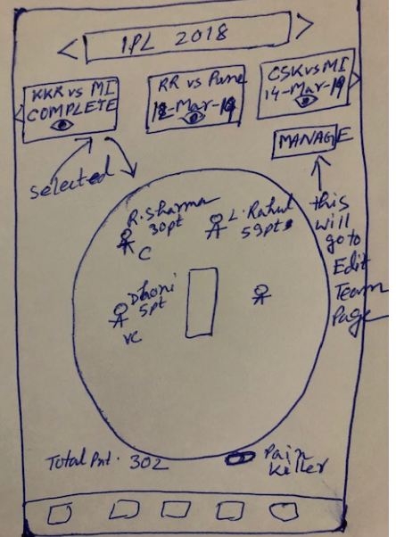

My Team page will be pretty much view only page for that user logged in with some basic navigation.
It will show horizon bar of Tournament First. Based on Tournament tap/select, it will fetch all the matches for that user using below API:

http://ec2-52-207-99-56.compute-1.amazonaws.com/FantasyCricketRest/api/fantasycricket/all-matches

Match will be shown as horizontal Tiles. Each Tile will show “Team1 vs Team2”, MatchStatus when MatchStatus = “COMPLETE”. If match status is not “COMPLETE”, it should display “MatchScheduledDate” instead of Status. And there will be View icon(EYE) in each tiles. Match Tiles order will be from COMPLETE(at left) to new one(at right). User can scroll left to right or right to left for any match to find.

When User clicks on COMPLETE match, it should display ground with Player Name, their points, Captain, Vice Captain, Total points, any booster used. If there is no booster used for that match, no need to display that. All view only information. For this call, data will come from below API,

http://ec2-52-207-99-56.compute-1.amazonaws.com/FantasyCricketRest/api/fantasycricket/user-team-match-details-with-players

When User clicks on any non COMPLETE match, it should display latest team without any points - Player Name, Captain, Vice Captain, if any booster applied. All view only information. For this call below API is being used,

http://ec2-52-207-99-56.compute-1.amazonaws.com/FantasyCricketRest/api/fantasycricket/user-team-players-with-details

There will be manage icon in this page somewhere , clicking on which it will take user to Edit Team/Manage Team page where he can change players.

